Reflective Log
Industry-Based Final Year Project
Weekly Entry Template
*You may include screenshots, links, images, and production samples in the “Evidence” section.
___________________________________________________________________________
Week: 7 - Nov. 11-12 - Start of Internship Activities
Student Name: Yehia Salem 229916
Pathway: Industry
Organisation / Project: BUE FCMM Social Media Team Internship
Hours Completed: 5
___________________________________________________________________________
1. Key Tasks completed this week
(Brief, factual overview)
- Learned the structure of the social media internship
- Recorded footage with teammates and Ms. Nadia at the Auditorium Building of industry representatives with Dr. Adel dean of FCMM
- Experimented with CapCut editing
___________________________________________________________________________
2. Significant Moments of Learning (Challenges, Decisions, or Problems Encountered)
(Identify one or two moments that taught you something important.)
Example prompts:
- What decision did you make?
- What did you notice during a task or meeting?
- What surprised you?
I noticed that Miss Nadia was very open about recording people. She would ask for people's permission beforehand for their consent to record them and then she would straight up start recording 6-second clips of each person right up in their face with no shyness. This taught me that when you're doing work and you have the permission to do said work from people that you're recording, you should really try your best to deliver the best product even if it's uncomfortable in your eyes.

Another thing that I learned was diplomacy with the people that I am working with or recording. In my first week, I was assigned to work with Dr. Hisham Soleiman, but unfortunately things didn't pan out. However, I did meet him again in this gathering of industry professionals and I shook his hand and made sure everything between us was okay. This taught me that being polite and diplomatic despite potential negative experiences is important to sustain good relationships for human decency and the sanctity of future projects.

___________________________________________________________________________
3. Reflection on What I Learned (Critical Reflection)- Optional
(This is where reflection becomes evaluation.)
Consider: Why was this moment important? What did it reveal about your skills or assumptions? How does it relate to professional standards or industry expectations?
(Apply one academic idea or industry principle.) Examples: Audience engagement, accuracy & verification, etc. (Include in-text citation if possible.)
This moment was important because it taught me that I am capable of acting openly without fear. This is something I didn't really see in myself before. I wasn't really used to recording people, so seeing Ms. Nadia do it and then doing it myself taught me that I am capable of doing it, and I'm capable of doing it well.
I'm not thinking here of the people that I'm recording, I'm thinking of my final project and how my audience will engage with the content that I'm producing. I want to make the very best content at the very best quality, so I will step out of my comfort zone to the very best job I can.
___________________________________________________________________________
4. Skills used and developed
e.g. Editing, Camera operation, Analytics & insights, Design / visual communication, Writing/scripting, Communication, Time management, Collaboration, Research, Critical thinking, Problem-solving
I learned CapCut editing and mobile camera operation along with time management skills and communication on the WhatsApp group in order to coordinate the release of videos. Collaboration with my peers was imperative in order to use their footage and have them use mine.
___________________________________________________________________________
5. Evidence Collected
Attach or reference production folder materials: Screenshots, Drafts, Feedback messages, Analytics, Photos
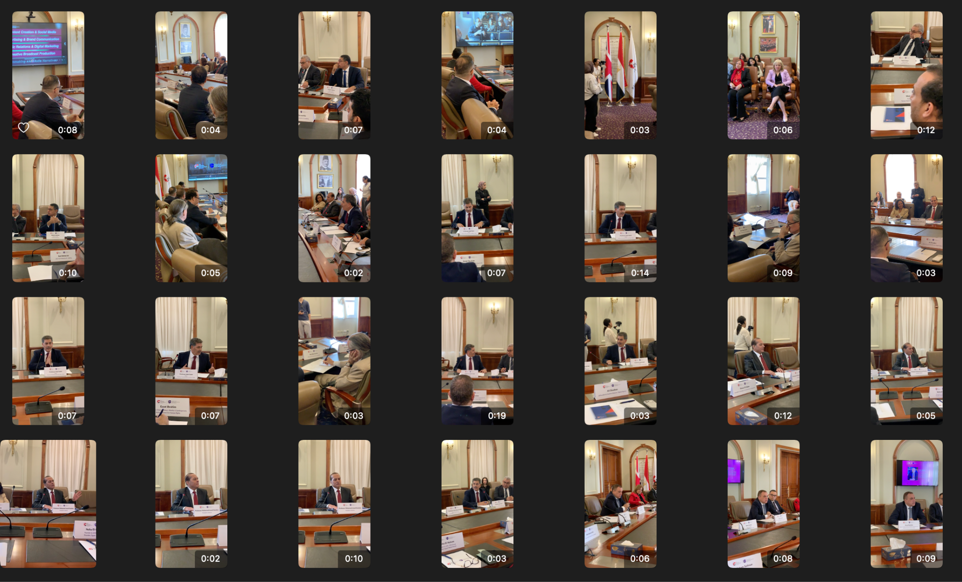
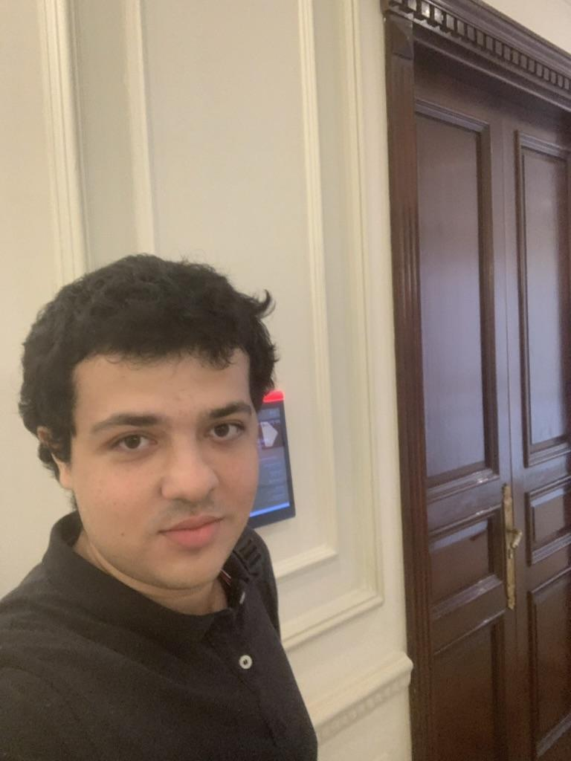
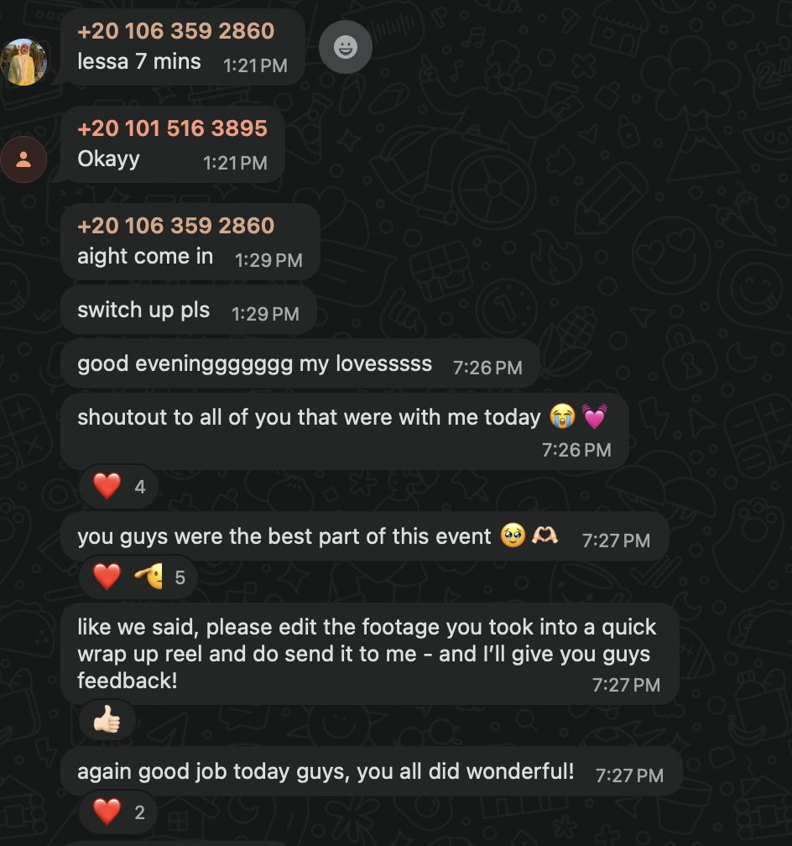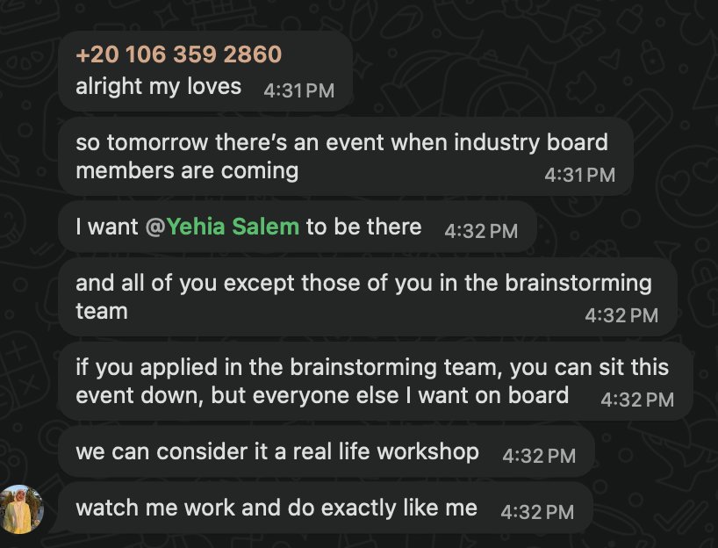
___________________________________________________________________________
6. Action Plan for Next Week
I will continue to refine my recording skills and learn to edit faster on CapCut, with the goal of being able to output a video within two hours of filming.
___________________________________________________________________________
Week: 8
Student Name: Yehia Salem 229916
Pathway: Industry
Organisation / Project: BUE FCMM Social Media Team Internship
Hours Completed: 5 - Total: 10
___________________________________________________________________________
1. Key Tasks completed this week
(Brief, factual overview)
- Recorded footage with teammates at classroom 4 of FCMM, recording guest speaker Salma
- Experimented with CapCut editing
___________________________________________________________________________
2. Significant Moments of Learning (Challenges, Decisions, or Problems Encountered)
(Identify one or two moments that taught you something important.)
Example prompts:
- What decision did you make?
- What did you notice during a task or meeting?
- What surprised you?
This week, Ms Nadia was not able to be with us, so She's assigned us to record the guest speaker without her being there. However, we all showed up and then started recording. I recorded a lot of footage, recorded nearly the entire talk, and my decision was to do that so I can create a recap. However, I was surprised that creating a recap will be a lot harder than I expected within the time frame.
___________________________________________________________________________
3. Reflection on What I Learned (Critical Reflection)- Optional
(This is where reflection becomes evaluation.)
Consider: Why was this moment important? What did it reveal about your skills or assumptions? How does it relate to professional standards or industry expectations?
(Apply one academic idea or industry principle.) Examples: Audience engagement, accuracy & verification, etc. (Include in-text citation if possible.)
I learned that I need to be realistic in my expectations of myself in order to not overburden myself with work that I cannot bear at the moment. I need to do the best I can. Without doing way more than expected
___________________________________________________________________________
4. Skills used and developed
e.g. Editing, Camera operation, Analytics & insights, Design / visual communication, Writing/scripting, Communication, Time management, Collaboration, Research, Critical thinking, Problem-solving
I learned CapCut editing and mobile camera operation along with time management skills and communication on the WhatsApp group in order to coordinate the release of videos. Collaboration with my peers was imperative in order to use their footage and have them use mine.
___________________________________________________________________________
5. Evidence Collected
Attach or reference production folder materials: Screenshots, Drafts, Feedback messages, Analytics, Photos
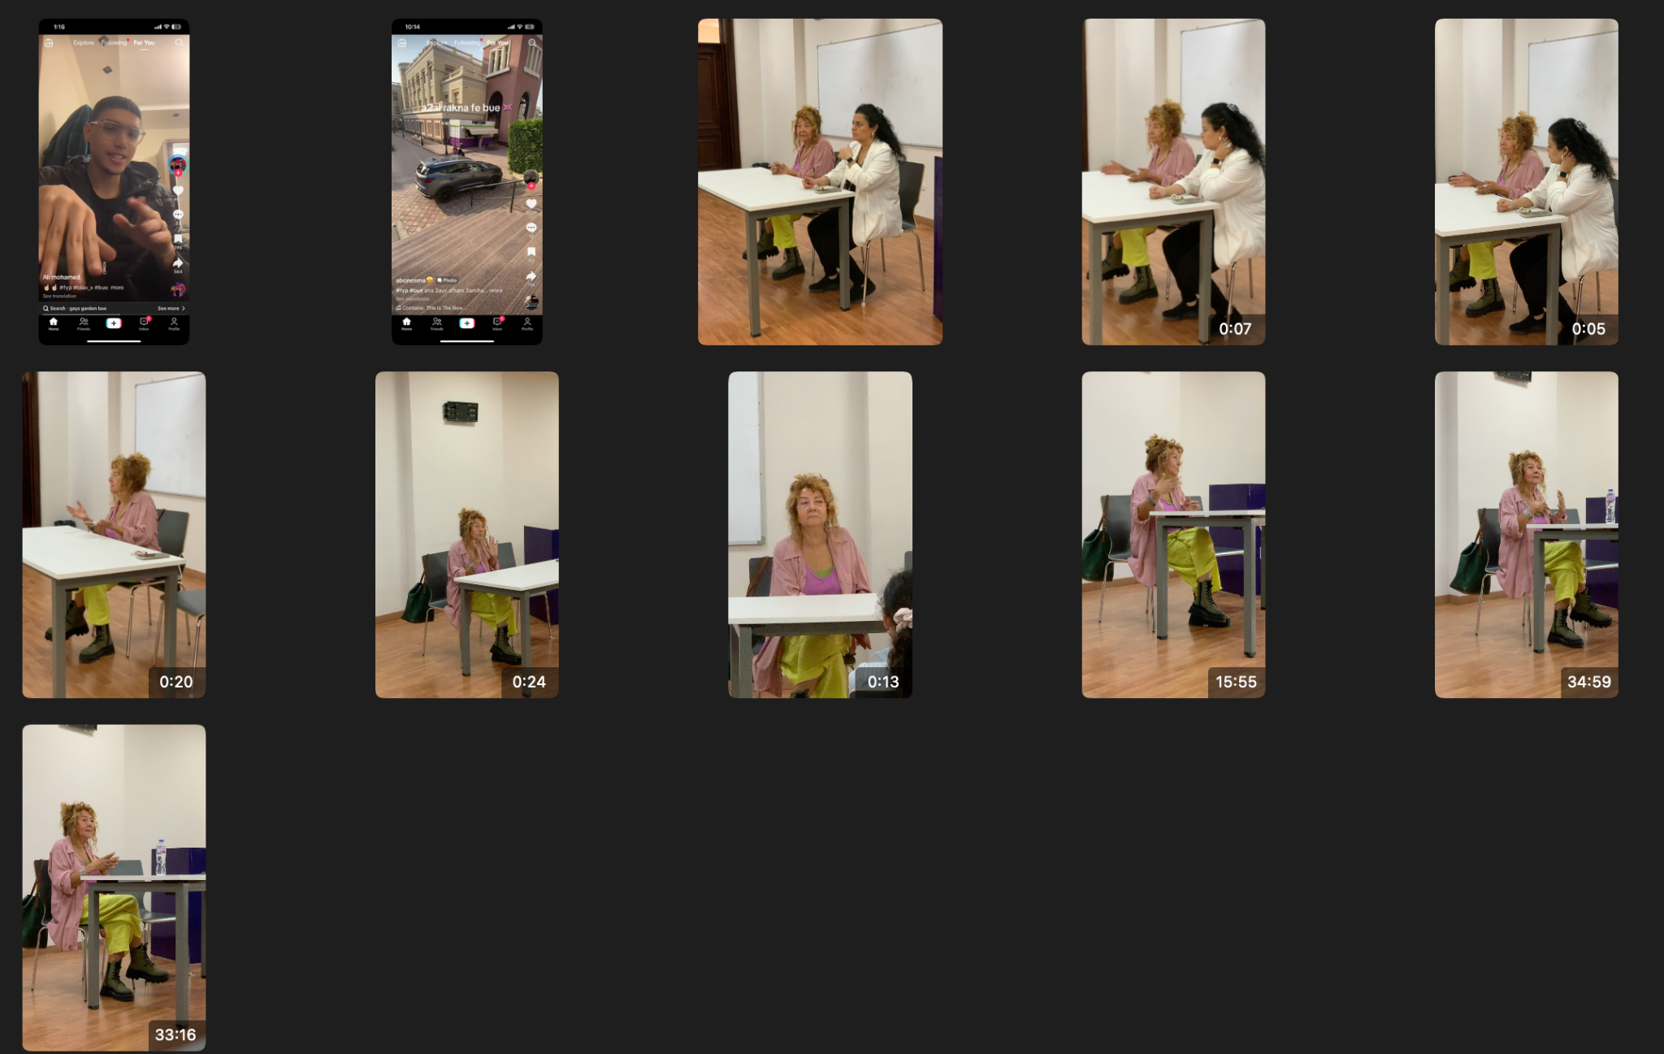
6. Action Plan for Next Week
I will continue to refine my recording skills and learn to edit faster on CapCut, with the goal of being able to output a video within two hours of filming.

Week: 12/13
Student Name: Yehia Salem 229916
Pathway: Industry
Organisation / Project: BUE FCMM Social Media Team Internship
Hours Completed: 1o Total: 20
___________________________________________________________________________
1. Key Tasks completed this week
(Brief, factual overview)
- Was assigned to the TikTok team and overseeing their projects
- Submitted my ideas for TikTok, Reels, and static posts
- Got ready for a Christmas rollout before the break.
___________________________________________________________________________
2. Significant Moments of Learning (Challenges, Decisions, or Problems Encountered)
(Identify one or two moments that taught you something important.)
Example prompts:
- What decision did you make?
- What did you notice during a task or meeting?
- What surprised you?
This week, I was assigned to oversee the TikTok team, which consists of three other people. One member asked me a question about how to submit. I informed her how to submit and how she should give in her thanks to this idea, but also give me a copy so I'm aware of what she's doingI noticed that I respond well and communicate well with other team members, which was not my expectation of myself.

I also noticed that it's difficult to research trends when you are actually actively looking for them and not just consuming them on TikTok. So I will choose to scroll more mindfully in the future so that I can use it in my work.

___________________________________________________________________________
3. Reflection on What I Learned (Critical Reflection)- Optional
(This is where reflection becomes evaluation.)
Consider: Why was this moment important? What did it reveal about your skills or assumptions? How does it relate to professional standards or industry expectations?
(Apply one academic idea or industry principle.) Examples: Audience engagement, accuracy & verification, etc. (Include in-text citation if possible.)

___________________________________________________________________________
4. Skills used and developed
e.g. Editing, Camera operation, Analytics & insights, Design / visual communication, Writing/scripting, Communication, Time management, Collaboration, Research, Critical thinking, Problem-solving
I learned CapCut editing and mobile camera operation along with time management skills and communication on the WhatsApp group in order to coordinate the release of videos. Collaboration with my peers was imperative in order to use their footage and have them use mine.
___________________________________________________________________________
5. Evidence Collected
Attach or reference production folder materials: Screenshots, Drafts, Feedback messages, Analytics, Photos
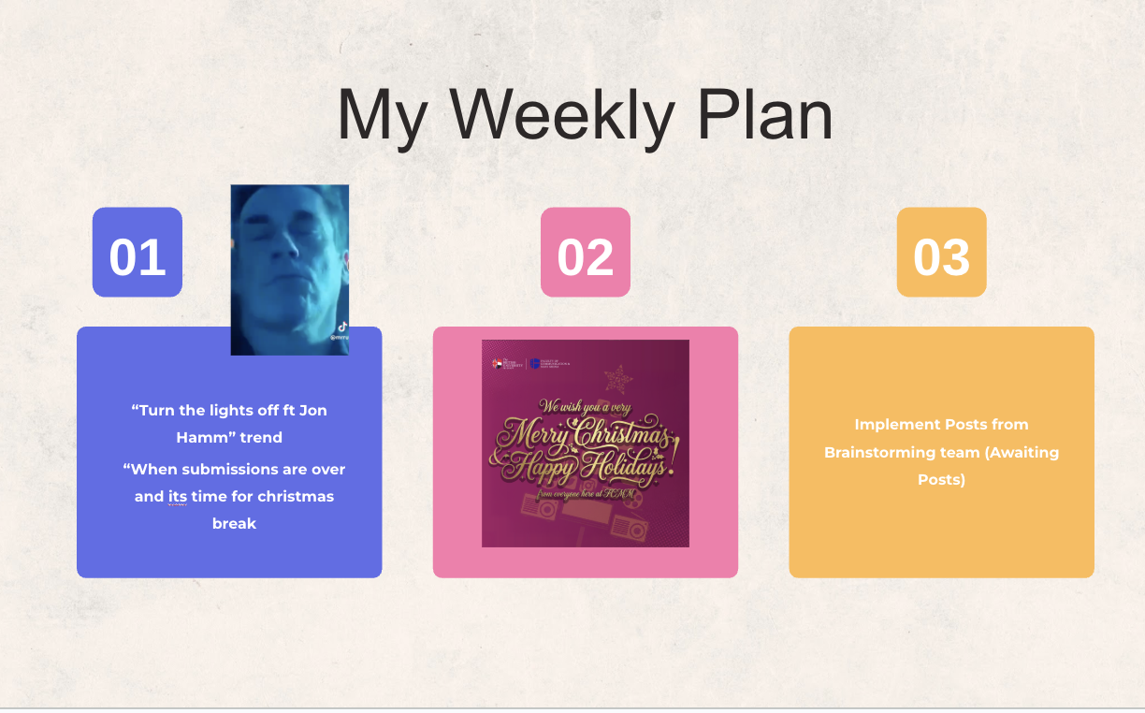
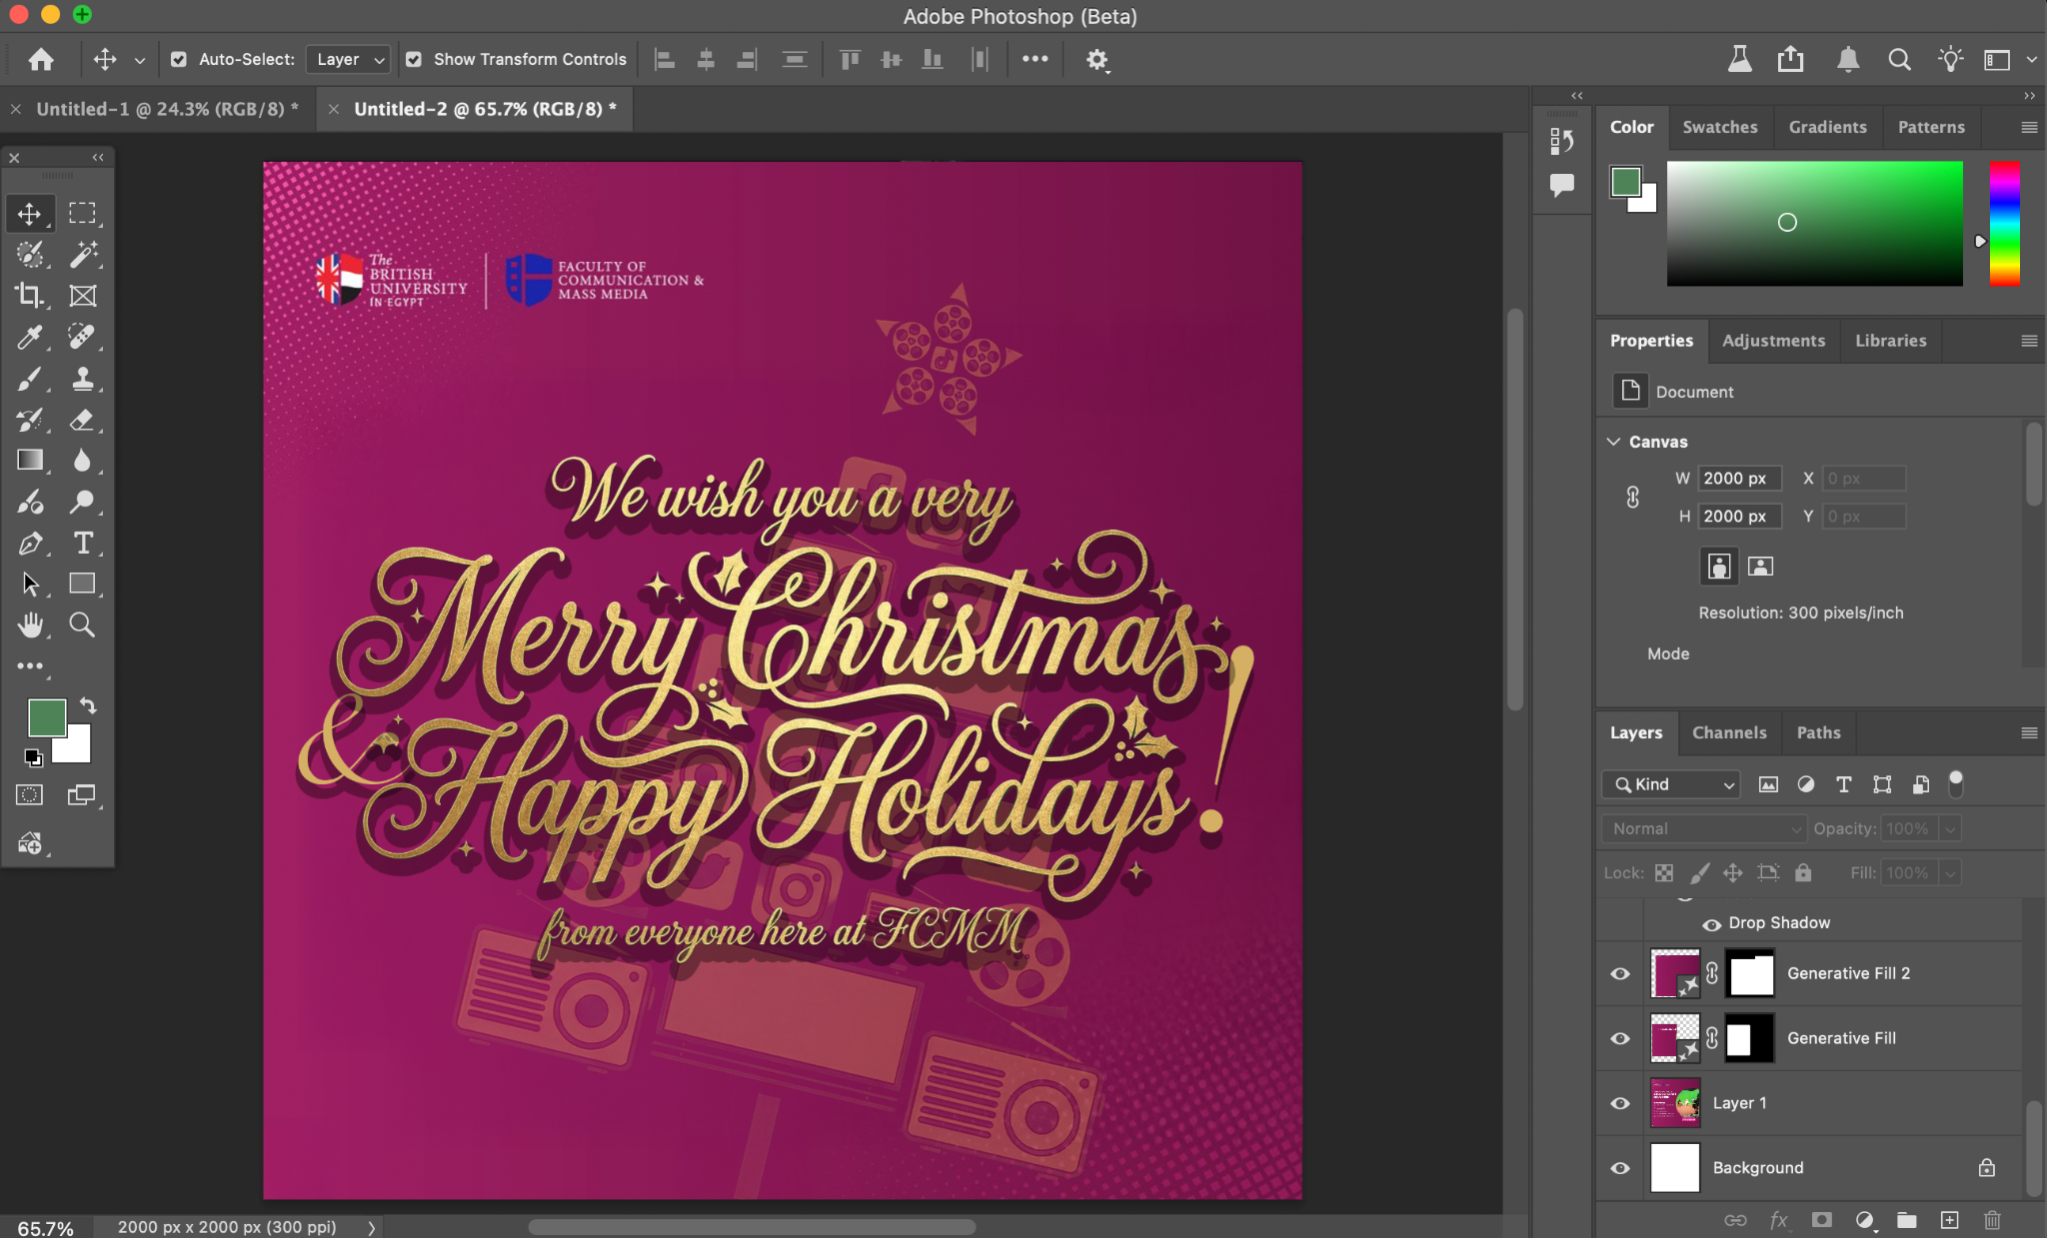
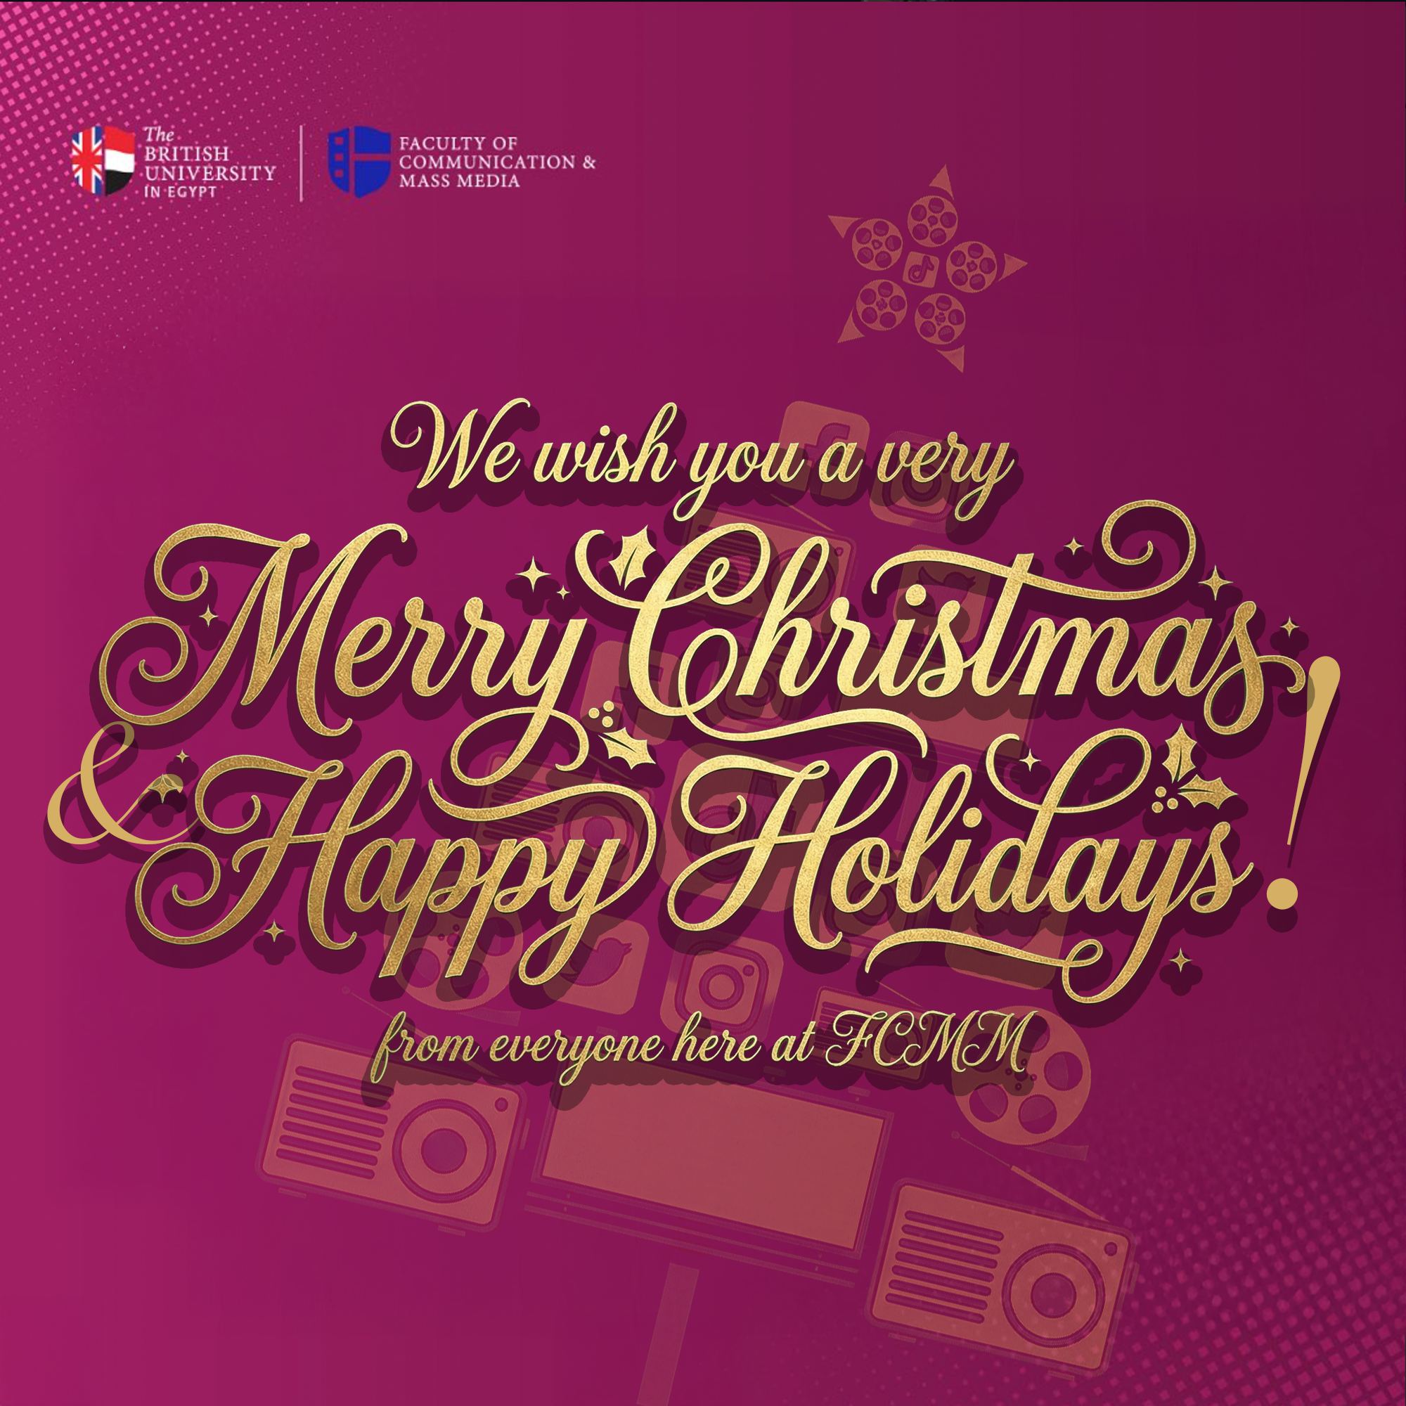
Week: 15 (Week 1 - Semester 2)
Student Name: Yehia Salem 229916
Pathway: Industry
Organisation / Project: BUE FCMM Social Media Team Internship
Hours Completed: 10 Total: 30
___________________________________________________________________________
1. Key Tasks completed this week
(Brief, factual overview)
- Was assigned to record IMC and Filming Discussions and February Open Day
- Recorded and prepped footage (encoded and labelled)
- Edited first draft of Open Day video
___________________________________________________________________________
2. Significant Moments of Learning (Challenges, Decisions, or Problems Encountered)
(Identify one or two moments that taught you something important.)
Example prompts:
- What decision did you make?
- What did you notice during a task or meeting?
- What surprised you?
This week was tough. I had to record back-to-back essentially for three days. The open day video taught me that some shoots will take a lot longer.

I was told to give a full overview of the entire event, so that's what I did. I covered everything from the beginning till the end, and I recorded everything. I had problems, majority technical problems, because I had to record my phone, and my phone has very limited storage. I had to keep pulling out my laptop and transferring files and recording some more and then doing that over and over again, but I got through, even though I was incredibly tired.

The day of the open day, I still locked in and did my work and tried my best and recorded everything I possibly could have. It took about six hours, this whole process, but it was fun as much as it was exhausting.

I recorded footage of all the faculties of FCMM, of the auditorium event of the tour. Unfortunately, not Mascomm's tour, because I could not find them, so I took footage from Nadia for that, then photos of people going home.
I was very surprised by how people look at you when you're recording and how you kind of actually have to ignore them. People are very confused as to why this guy is recording everything, and some people did ask me. I told them honestly what I was doing, and they wished me luck, so communication is important. You should communicate with the people that you're recording, and I learned to do that.
For the filming and IMC discussions, I did go and film, and it was very fun as well, but it was also awkward having to get in the face of my peers to record them. I've had people ask me to not include them in the footage and not record them all together, and of course I respected their wishes because consent is important. I continued to ignore how people were looking at me and just did my work as I was supposed to.
___________________________________________________________________________
3. Reflection on What I Learned (Critical Reflection)- Optional
(This is where reflection becomes evaluation.)
Consider: Why was this moment important? What did it reveal about your skills or assumptions? How does it relate to professional standards or industry expectations?
(Apply one academic idea or industry principle.) Examples: Audience engagement, accuracy & verification, etc. (Include in-text citation if possible.)
This day was very important to me because it taught me how to apply discipline to oneself, even though you really don't want to do it, you still have to. Getting out of your comfort zone put you in a place where you might actually enjoy things more, even if it might not seem that way at first. It also revealed to me that I am more capable and more willing to push myself if necessary, and that gives me a good amount of confidence.
___________________________________________________________________________
4. Skills used and developed
e.g. Editing, Camera operation, Analytics & insights, Design / visual communication, Writing/scripting, Communication, Time management, Collaboration, Research, Critical thinking, Problem-solving
I got better at:
- mobile camera operation
- camera operation none the less
- verbal communication with others
- editing
- this was a very big test of my editing skills
- problem solving when things didn't go my way
For example, with the storage on my phone
___________________________________________________________________________
5. Evidence Collected
Attach or reference production folder materials: Screenshots, Drafts, Feedback messages, Analytics, Photos

Week: 16 (Week 2 - Semester 2)
Student Name: Yehia Salem 229916
Pathway: Industry
Organisation / Project: BUE FCMM Social Media Team Internship
Hours Completed: 10 Total: 40
___________________________________________________________________________
1. Key Tasks completed this week
(Brief, factual overview)
This week, I took feedback from Nadia and made the final version of the Open Day video. I edited the IMC and filming discussions.
___________________________________________________________________________
2. Significant Moments of Learning (Challenges, Decisions, or Problems Encountered)
(Identify one or two moments that taught you something important.)
Example prompts:
- What decision did you make?
- What did you notice during a task or meeting?
- What surprised you?
This week I learned that editing is hard. Editing is really, really, really hard. Why is that? Because it takes a lot of time. In order to do a good edit, you need to:
- find a trending audio so that your video stays relevant
- time your clips to the beat of that audio so that it feels holistic and easy to watch
- record a voiceover, so you have to write a script as well
- record the voiceover process, the audio, and then put it in the timeline
- cut that up as well
- captions. Oh my god, captions. You have to create captions for your video in case someone's not listening, because a lot of people use TikTok with their sound off in public places and such
Of course, dealing with the editing software itself (Premiere and Cap Cut) both have their strengths and weaknesses. Premiere is really good at fine detail, so I use that for open day, but for quick edits I used Cap Cut for the speed of it. I was surprised by how much time it took, genuinely, to edit. It's like I was figuratively ripping my hair out looking at the screen, trying to figure out how I'm going to do this on time. I did eventually do it, but it was a struggle.

___________________________________________________________________________
3. Reflection on What I Learned (Critical Reflection)- Optional
(This is where reflection becomes evaluation.)
Consider: Why was this moment important? What did it reveal about your skills or assumptions? How does it relate to professional standards or industry expectations?
(Apply one academic idea or industry principle.) Examples: Audience engagement, accuracy & verification, etc. (Include in-text citation if possible.)
This moment revealed to me that I am capable of problem-solving and building an edit that looks clean and respectable while keeping engagement high. It was not easy, and I did learn a lot about how to write a TikTok script and how to edit a TikTok video. I am really proud of the output that I gave. I believe it relates to professional standards in that you have to start somewhere. You cannot become a professional without learning how to do something first, so you have to be kind to yourself and learn, but also give the best output you possibly can.
___________________________________________________________________________
4. Skills used and developed
e.g. Editing, Camera operation, Analytics & insights, Design / visual communication, Writing/scripting, Communication, Time management, Collaboration, Research, Critical thinking, Problem-solving
This week I got better at editing, script writing, and voice over. I had to problem solve as well because I had my power go out five times this week. This obviously affected my edits and some of the footage, but I did what I could with whatever happened and learned to save. I save a lot now. Control S is my new catch phrase.
___________________________________________________________________________
5. Evidence Collected
Attach or reference production folder materials: Screenshots, Drafts, Feedback messages, Analytics, Photos

